
Foundation University Islamabad
School of Science and Technology

Name: Hunaina Yasir Roll Number: 073
Subject: Programming Fundamentals Section: B

LAB REPORT# 3
3.1: ASCII Values in C++
Imp Note: Find out the differences between getch(), getche(), and getchar() before the lab session.
Every character has an ASCII value. Write a C++ program that takes a single character as input from the user, calculates its ASCII code, and then displays the character along with its corresponding ASCII code. The ASCII Table is given above for your reference. Indent your code and include comments for improving the readability of your code. Your program should have the following interface.
HINT:
char c
cout << "Enter a Character and I will tell you it’s ASCII value:";
cin >> c;
int A = c;
cout << "ASCII Value of " << c << " is " << A;

Enter a Character and I will tell you it’s ASCII value: B

The ASCII value is: 66

SOURCE CODE:
#include <iostream>
using namespace std;

int main()
{
char c;
cout << "Enter a character: ";
cin >> c;
int A = c;
cout << "The ACII value of the character is: " << A;
return 0;
}
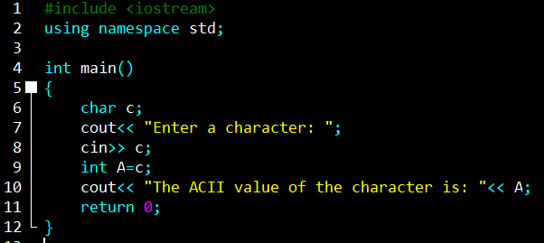

OUTPUT:
Enter a character: H
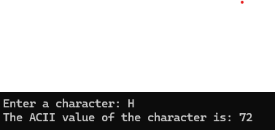
The ACII value of the character is: 72

3.2: Write a C++ program that takes an integer input in the range of 0 to 127 as an ASCII code from the user. The program should then convert this ASCII code into the corresponding character and display it on the screen.
Enter an ASCII code (integer 0 to 127): 66

The character with given ASCII code: B

SOURCE CODE:
#include <iostream>
using namespace std;

int main()
{
int num;
char A;
cout << "Enter a number to print its ACII value (0 to 127) : ";
cin >> num;
A = num;
cout << "\n The ACII value of the number is: " << A;
return 0;
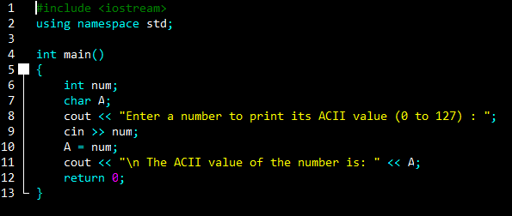
}

OUTPUT:
Enter a number to print its ACII value (0 to 127) : 67

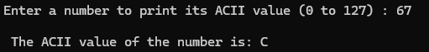
The ACII value of the number is: C

3.3: Write a C++ program, which takes a character input from the user and prints its ASCII value on the screen. You must use all built-in functions for taking character input from the user (like getch(), getche(), getchar() etc.), one by one. ASCII Table is included in Appendix A for your reference. Indent your code and include comments for improving the readability of your code. Your program should have the following interface.
HINT:
#include <conio.h> // For getch and getche functions
SOURCE CODE:
#include <iostream>
#include <conio.h>
using namespace std;

int main()
{
char c, b, d;
cout << "Enter 1 character to print its ACII value: ";
c = getch();
cout << "\nEnter 2 character to print its ACII value: ";
b = getche();
cout << "\nEnter 3 character to print its ACII value: ";
d = getchar();
int A = c;
int B = b;
int C = d;
cout << "\n The value of the ACII character 1 is " << A;
cout << "\n The value of the ACII character 2 is " << B;
cout << "\n The value of the ACII character 3 is " << C;
return 0;
}
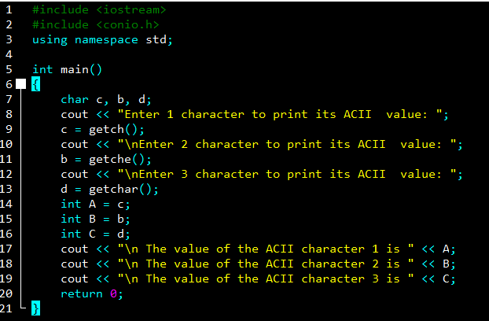

OUTPUT:
Enter 1 character to print its ACII value:
Enter 2 character to print its ACII value: J
Enter 3 character to print its ACII value: D

The value of the ACII character 1 is 104
The value of the ACII character 2 is 74
The value of the ACII character 3 is 68

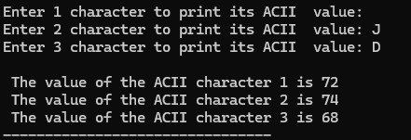
3.4: Write a C++ program that takes three characters one by one as input from the user, calculates its ASCII codes, and then displays the sum of all ASCII codes.
SOURCE CODE:
#include <iostream>
#include <conio.h>
using namespace std;

int main()
{
char c1, c2, c3;
cout << "Enter 1st character to print its ACII value: ";
c1 = getche();
cout << "\nEnter 2nd charcter to print its ACII value: ";
c2 = getche();
cout << "\nEnter 3rd to character print its ACII value: ";
c3 = getche();

int A = c1;
int B = c2;
int C = c3;
cout << "\nACII code of the character 1 is: " << A;
cout << "\nACII code of the character 2 is: " << B;
cout << "\nACII code of the character 3 is: " << C;

cout << "\nThe sum of all ACII is: " << A+B+C;
return 0;
}
OUTPUT:
Enter 1st character to print its ACII value: A
Enter 2nd charcter to print its ACII value: B
Enter 3rd to character print its ACII value: C
ACII code of the character 1 is: 65
ACII code of the character 2 is: 66
ACII code of the character 3 is: 67
The sum of all ACII is: 198
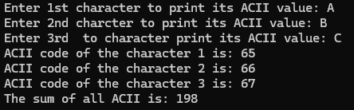

3.5: Write a C++ program that takes two integer values, x, and y, as input from the user. The program should then perform several comparisons between these two values and display the results using Boolean variables (1 for true statement and 0 for false statement). Specifically, it should check if x is equal to y, greater than y, less than y, greater than or equal to y, and less than or equal to y.
Hint
Use Comparison Operator Table
int E = x == y; //check x equals to y or not and stores 1 or 0 in E

SOURCE CODE:
#include <iostream>
using namespace std;

int main()
{
int x, y;

cout << "Enter first number (x): ";
cin >> x;
cout << "Enter second number (y): ";
cin >> y;

int eq = x == y;
int greater = x > y;
int less = x < y;
int gequal = x >= y;
int lequal = x <= y;

cout << "x == y : " << eq << endl;
cout << "x > y : " << greater << endl;
cout << "x < y : " << less << endl;
cout << "x >= y : " << gequal << endl;
cout << "x <= y : " << lequal << endl;

return 0;
}
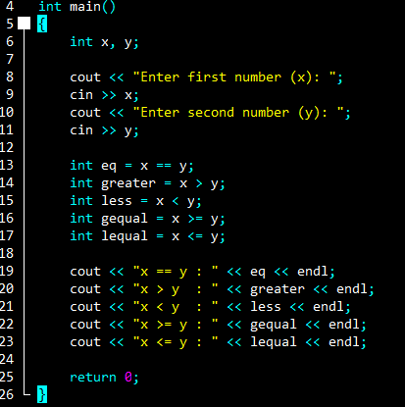
OUTPUT:
Enter first number (x): 2
Enter second number (y): 3
x == y : 0
x > y : 0
x < y : 1
x >= y : 0
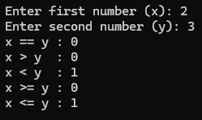
x <= y : 1

3.6: Write a C++ program that takes temperature as input from the user. The program should display the results using logical operators (1 for bearable and 0 for unbearable).
Hint
Bearable temperature 0 to 60
Use logical && operator.

SOURCE CODE:
#include <iostream>
using namespace std;

int main()
{
int temp;
cout << "Enter temperature: ";
cin >> temp;

int b = temp >= 0 && temp <= 60;

cout << "Bearable (1=True, 0=False): " << b << endl;

return 0;
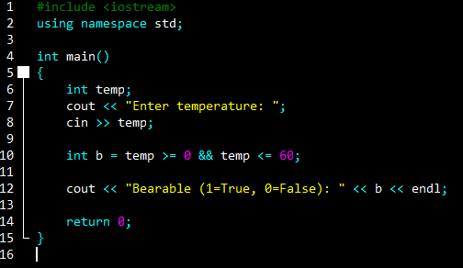
}

OUTPUT:
Enter temperature: 37
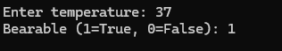
Bearable (1=True, 0=False): 1

3.7: Write a C++ program to determine if a customer is eligible for a discount or not (Display 1 if eligible and 0 if not eligible) by checking if the age of the customer is above 50 OR if their total purchase amount exceeds a certain 20,000 PKR.
Hint
Use logical || operator.
SOURCE CODE:

#include <iostream>
using namespace std;

int main()
{
int age, amt;
cout << "Enter age: ";
cin >> age;
cout << "Enter total purchase amount: ";
cin >> amt;

int dis = age > 50 || amt > 20000;

cout << "Eligible for discount (1=True, 0=False): " << dis << endl;

return 0;
}
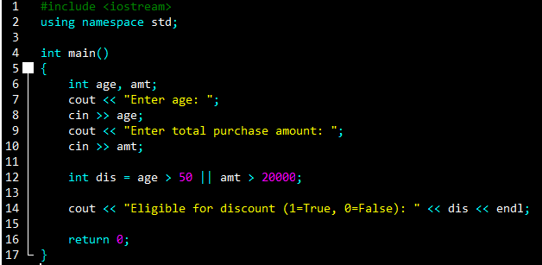

OUTPUT:
Enter age: 19
Enter total purchase amount: 340000
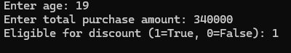
Eligible for discount (1=True, 0=False): 1

3.8: Write a C++ program that takes 4 integer values, a, b, c, and d, as input from the user and calculates the output according to the given expressions
a + b * c / d =?
(a + b) * c / d =?
((a + b) * c) / d =?
(a + b) * (c / d) =?
a + (b * c) / d =?

SOURCE CODE:
#include <iostream>
using namespace std;

int main()
{
int a, b, c, d;
cout << "Enter value of a: ";
cin >> a;
cout << "Enter value of b: ";
cin >> b;
cout << "Enter value of c: ";
cin >> c;
cout << "Enter value of d: ";
cin >> d;

cout << (a + b * c / d) << " = a + b * c / d" << endl;
cout << ((a + b) * c / d) << " = (a + b) * c / d" << endl;
cout << (((a + b) * c) / d) << " = ((a + b) * c) / d" << endl;
cout << ((a + b) * (c / d)) << " = (a + b) * (c / d)" << endl;
cout << (a + (b * c) / d) << " = a + (b * c) / d" << endl;

return 0;
}

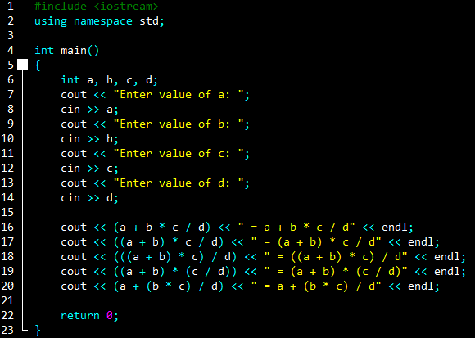

OUTPUT:
Enter value of a: 2
Enter value of b: 3
Enter value of c: 4
Enter value of d: 5
4 = a + b * c / d
4 = (a + b) * c / d
4 = ((a + b) * c) / d
0 = (a + b) * (c / d)
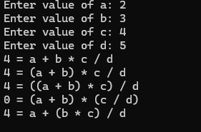
4 = a + (b * c) / d

Exercises:
3.1: Write a C++ program that reads a three-digit number from the user and separates its digits. The output of your program should be as below. Indent your code and include comments for improving the readability of your code.
Enter a three-digit number: 547.
There are 5 hundreds, 4 Tens, and 7 Ones in 547.

Hint:
int h, t, o; // hundreds, tens, units
o=n%10; //ones
t=(n/10)%10; //tens
h=(n/100)%10; // hundreds

SOURCE CODE:
#include <iostream>
using namespace std;

int main() {
int n, h, t, o;

// taking a three-digit number from user
cout << "Enter a three-digit number: ";
cin >> n;

o = n % 10; // ones place
t = (n / 10) % 10; // tens place
h = (n / 100) % 10; // hundreds place

cout << "Hundreds: " << h << endl;
cout << "Tens: " << t << endl;
cout << "Ones: " << o << endl;

return 0;
}
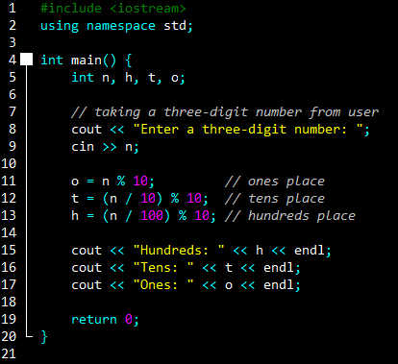
OUTPUT:
Enter a three-digit number: 456
Hundreds: 4
Tens: 5
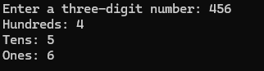
Ones: 6

3.2: Write a C++ program that prompts the user to enter two integer values, stores them in variables named ‘a’ and ‘b’, calculates the following expressions, and displays the results on the screen. The output of your program must be presentable. You must use the minimum possible number of parentheses for evaluating these expressions.
(a + b)² = a² + 2ab + b²
(a - b)² = a² - 2ab + b²

SOURCE CODE:
#include <iostream>
using namespace std;

int main() {
int a, b;

// taking input from user
cout << "Enter first number (a): ";
cin >> a;
cout << "Enter second number (b): ";
cin >> b;

// calculating both expressions
int expr1 = a * a + 2 * a * b + b * b;
int expr2 = a * a - 2 * a * b + b * b;

// showing results
cout << "(a + b)^2 = " << expr1 << endl;
cout << "(a - b)^2 = " << expr2 << endl;

return 0;
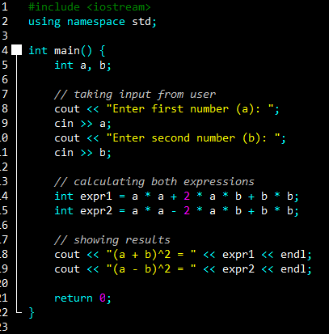
}

OUTPUT:
Enter first number (a): 5
Enter second number (b): 7
(a + b)^2 = 144
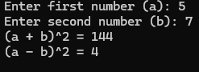
(a - b)^2 = 4

